SERMON FOR APRIL 14, 2013 – Easter 3
The First Chinese Church of Christ in Hawai‘i
United Church of Christ

7:45 & 10:30 Worship Services
Scripture: Acts 9:1-6 (7-20 Focus); John 21:1-19
Message: “Easter 3: We Are an Easter People
@ TFCCCH!”

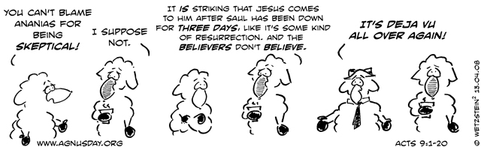
Acts 9:1-20

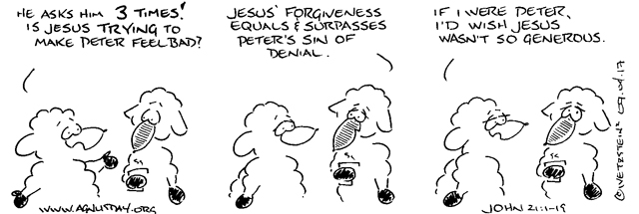
John 21:1-19

Gathering in the Word
Hearing the Word
Acts 9:1-20 (NIV 2011)
“Jesus confronts and meets-head-on with Saul to force him to recognize his self-inflicted (one that you cause yourself) spiritual blindness which then opens a path and way for Saul to experience healing.

Saul’s Conversion
9 Meanwhile, Saul was still breathing out murderous threats against the Lord’s disciples. He went to the high priest ² and asked him for letters to the synagogues in Damascus, so that if he found any there who belonged to the Way, whether men or women, he might take them as prisoners to Jerusalem. ³ As he neared Damascus on his journey, suddenly a light from heaven flashed around him. ⁴ He fell to the ground and heard a voice say to him, “Saul, Saul, why do you persecute me?” ⁵ “Who are you, Lord?” Saul asked. “I am Jesus, whom you are persecuting,” he replied. ⁶ “Now get up and go into the city, and you will be told what you must do.” ⁷ The men traveling with Saul stood there speechless; they heard the sound but did not see anyone. ⁸ Saul got up from the ground, but when he opened his eyes he could see nothing. So they led him by the hand into Damascus. ⁹ For three days he was blind, and did not eat or drink anything.
¹⁰ In Damascus there was a disciple named Ananias. The Lord called to him in a vision, “Ananias!” “Yes, Lord,” he answered. ¹¹ The Lord told him, “Go to the house of Judas on Straight Street and ask for a man from Tarsus named Saul, for he is praying. ¹² In a vision he has seen a man named Ananias come and place his hands on him to restore his sight.” ¹³ “Lord,” Ananias answered, “I have heard many reports about this man and all the harm he has done to your holy people in Jerusalem. ¹⁴ And he has come here with authority from the chief priests to arrest all who call on your name.” ¹⁵ But the Lord said to Ananias, “Go! This man is my chosen instrument to proclaim my name to the Gentiles and their kings and to the people of Israel. ¹⁶ I will show him how much he must suffer for my name.” ¹⁷ Then Ananias went to the house and entered it. Placing his hands on Saul, he said, “Brother Saul, the Lord—Jesus, who appeared to you on the road as you were coming here—has sent me so that you may see again and be filled with the Holy Spirit.” ¹⁸ Immediately, something like scales fell from Saul’s eyes, and he could see again. He got up and was baptized, ¹⁹ and after taking some food, he regained his strength.

Saul in Damascus and Jerusalem
Saul spent several days with the disciples in Damascus. ²⁰ At once he began to preach in the synagogues that Jesus is the Son of GOD.
-------
John 21:1-19. (20-22) (NIV 2011)
Jesus challenges disciples to cast their nets on the "wrong" side of the boat, then challenges Peter's love for him and calls him to "feed my sheep."

Jesus and the Miraculous Catch of Fish
21 Afterward Jesus appeared again to his disciples, by the Sea of Galilee. It happened this way: ² Simon Peter, Thomas (also known as Didymus), Nathanael from Cana in Galilee, the sons of Zebedee, and two other disciples were together. ³ “I’m going out to fish,” Simon Peter told them, and they said, “We’ll go with you.” So they went out and got into the boat, but that night they caught nothing.
⁴ Early in the morning, Jesus stood on the shore, but the disciples did not realize that it was Jesus. ⁵ He called out to them, “Friends haven’t you any fish?” “No,” they answered. ⁶ He said, “Throw your net on the right side of the boat and you will find some.” When they did, they were unable to haul the net in because of the large number of fish. ⁷ Then the disciple whom Jesus loved said to Peter, “It is the Lord!” As soon as Simon Peter heard him say, “It is the Lord,” he wrapped his outer garment around him (for he had taken it off) and jumped into the water. ⁸ The other disciples followed in the boat, towing the net full of fish, for they were not far from shore, about a hundred yards. ⁹ When they landed, they saw a fire of burning coals there with fish on it, and some bread. ¹⁰ Jesus said to them “Bring some of the fish you have just caught.” ¹¹ So Simon Peter climbed back into the boat and dragged the net ashore. It was full of large fish, 153, but even with so many the net was not torn. ¹² Jesus said to them “Come and have breakfast.” None of the disciples dared ask him, “Who are you?” They knew it was the Lord. ¹³ Jesus came, took the bread and gave it to them, and did the same with the fish. ¹⁴ This was now the third time Jesus appeared to his disciples after he was raised from the dead.

Jesus Reinstates Peter
¹⁵ When they had finished eating, Jesus said to Simon Peter, “Simon son of John, do you love me more than these?” “Yes, Lord,” he said, “you know that I love you.” Jesus said, “Feed my lambs.” ¹⁶ Again Jesus said, “Simon son of John, do you love me?” He answered, “Yes, Lord, you know that I love you.” Jesus said, “Take care of my sheep.” ¹⁷ The third time he said to him, “Simon son of John, do you love me?” Peter was hurt because Jesus asked him the third time, “Do you love me?” He said, “Lord, you know all things; you know that I love you.” Jesus said, “Feed my sheep. ¹⁸ Very truly I tell you, when you were younger you dressed yourself and went where you wanted; but when you are old you will stretch out your hands, and someone else will dress you and lead you where you do not want to go.” ¹⁹ Jesus said this to indicate the kind of death by which Peter would glorify GOD. Then he said to him, “Follow me!”
-------

Doing the Word
On this 3rd Sunday of Easter, what is the Word of GOD for us?
- ONE: Life and Faith is about GOD—not about us!

- TWO: We are all salvageable! Our GOD restores us! (from being rejected, used, damaged goods by others, did something bad in the eyes of the law and by Christians in the church)

- THREE: FORGIVENESS is the key to Bridge Building and Reconciliation!
Sent in the Word

